**Project Design Phase-II**

**Data Flow Diagram & User Stories**

| Date | 16th june 2025 |
| --- | --- |
| Team ID | LTVIP2025TMID44631 |
| Project Name | ShopSmart: Your Digital Grocery Store Experience |
| Maximum Marks | 4 Marks |

**Data Flow Diagrams:**

A **Data Flow Diagram (DFD)** illustrates how data moves within the Resolve Now platform. It captures how user interact with the system, how information flows between different components, and where the data is stored.

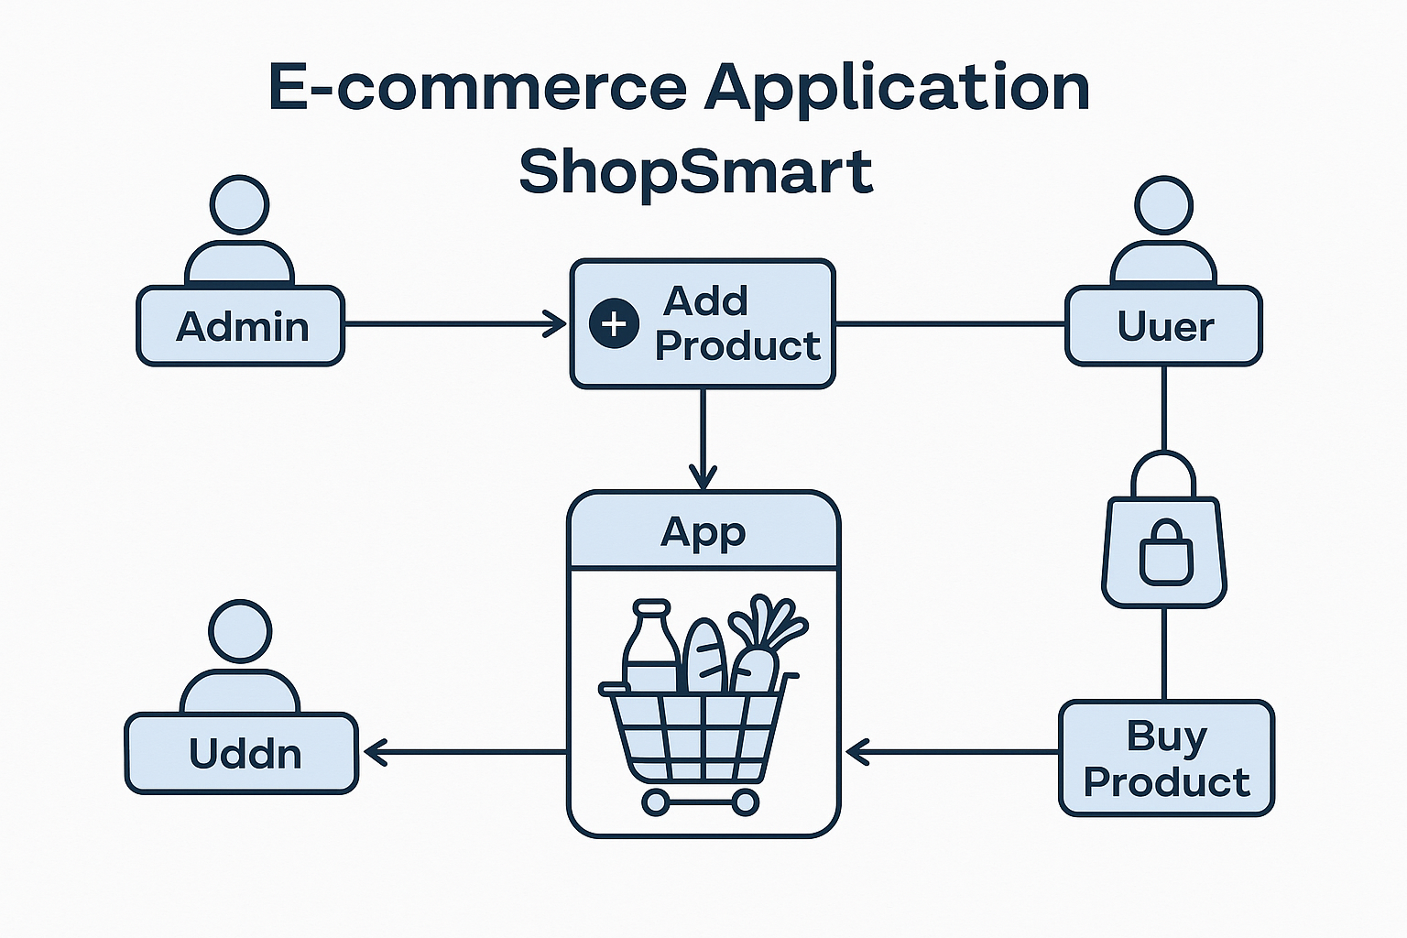

**User Story Table – Shop Smart**

| **User Type** | **Functional Requirement (Epic)** | **User Story / Task** | **Acceptance Criteria** | **Priority** | **Release** |
| --- | --- | --- | --- | --- | --- |
| **Admin** | | Product Management | | --- | | As an admin, I can add new grocery products to the app. | Products appear in the product listing for users. | High | Sprint-1 |
| **Admin** | Inventory Control | | | As an admin, I can update or delete existing products. | | --- |  |  | | --- | | | --- | --- | --- | | | Changes are reflected in real-time to users. | | --- |  |  | | --- | | High | Sprint-1 |
| **User** | | Product Browsing | | --- |  |  | | --- | | | As a user, I can browse all available grocery products. | | --- |  |  | | --- | | | All listed products are visible with details like price and quantity. | | --- |  |  | | --- | | Medium | Sprint-2 |
| **Client** | | Add to Cart | | --- |  |  | | --- | | | As a user, I can add items to my shopping cart. | | --- |  |  | | --- | | | Selected items appear in the cart with correct quantity and total. | | --- |  |  | | --- | | High | Sprint-2 |
| **Admin** | | Order Management | | --- |  |  | | --- | | | As an admin, I can view and process user orders. | | --- |  |  | | --- | | | Admin dashboard shows new orders and their statuses. | | --- |  |  | | --- | | High | Sprint-1 |